**Writing Task -1 (Vocabulary)**

**Reporting Verbs:**

* **According** to the image, bar…..
* The graph **illustrates** a decrease in revenue
* The graph **indicates** men are highly educated
* The bar graph **presents**
* The data **provide**
* The pie graph **reveals**

**Reporting Adverbs:**

* **Abruptly-unexpectedly, suddenly**
  + 
* **Approximately-roughly, about(I don’t have the specific number)**
  + 
* **Dramatically-intensely by large amount, greatly**
  + 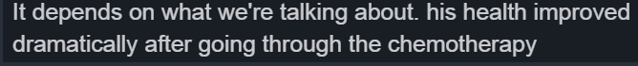
* **Exactly-absolutely**
* **Unexpectedly**
  + 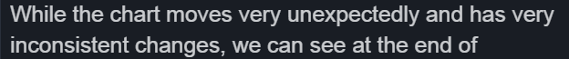
* **Gradually-slowly but consistently**
  + 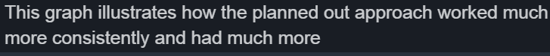
* **Markedly-very noticeable, significant** 
  + 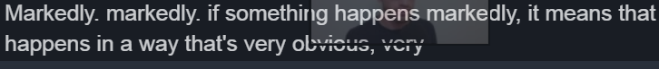
  + 
* **Roughly-less certain**
* **Significantly**
  + 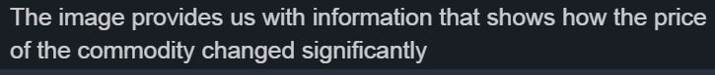
* **Slightly –little changes**
  + 
* **Slowly-gradually** 
  + 
* **Specifically-very specific(no guessing)**
* **Steadily-regular change**

**Increasing Trends:**

* **raise – increase, climb, jump, skyrocket, surge , shoot up(Sudden increase)**
* **Gradually, pick up(slow increase)**
* **Recover (to go up after a drop)**

**Decrease Trend:**

* **plummet, plunge, collapse[rock bottom](Sudden decrease)** 
* **Slip, slump, deteriorate, decline , drop, slide(Gradual drop)**
* **Dip(not permanent decrease, a small fluctuation )** 
* **Fall or drop**

**Frequent Change:**

* **Fluctuates (no consistency ,unpredictable movement)**

**Writing Task – 2**

**Opinion Transitions**

* **“I feel that, I personally think, I personally believe that, from my point of view, as far as I’m concerned”.**

**Introducing Information:**

* **Moreover, furthermore, in addition, likewise , on top of that**

**Comparing and contrasting:**

* **“However, in contrast, by comparison, meanwhile, on the other hand, on the one hand”.**

**Conditional Sentences: (If, will)**

* 
* 
* 

**Give Examples:**

* **For example, for instance, the best example is, a very good example is**

**Describe Result:**

* **Accordingly, as a consequence, as a result, for that reason, on that account and therefore, therefore, as a result, for that reason**

**Speaking Vocabulary**

**Question Transition:**

* **Why? And give more information**
* **Add personal story**

**Sorry🡪 I didn’t understand**

**I got it🡪 I can understand**

**Filler Words:**

* **Thinking🡪 well that’s an interesting question, hmm let’s see**

**Writing Task Tips and Checklist**

* Use variety of sentence variety like **complex sentence(5), conditional statement(if) , modal verbs(might), question type**
  + - * **Meanwhile, while**
* 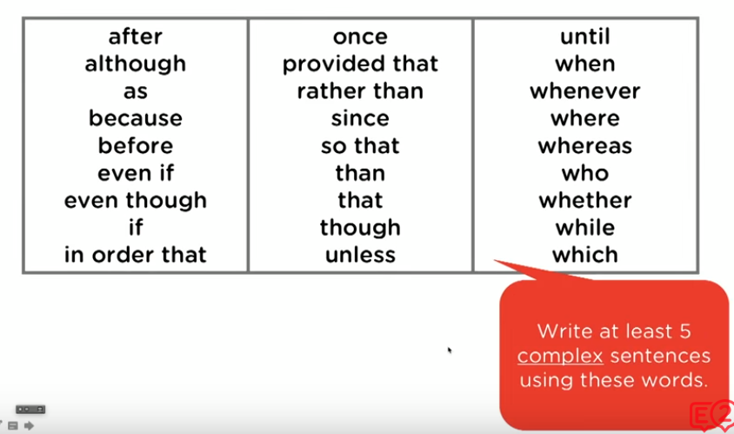
* Describe **relevant features** in the graph(writing task 1)
* Describe only **key feature**
* Structure(Paraphrase the question, key feature and 2 paragraph) and flow (use complex sentence)-Plan the structure before
* Use Vocabulary (use synonyms for same word)
* Write more than >150 words and >250 words
* **Writing Task 1:**
  + Paraphrase the question
  + Key features
  + Comparison 1
  + Comparison 2